Project Report on

SMART HEALTHCARE SYSTEM USING

AI & BLOCKCHAIN
Submitted in partial fulfilment of the requirements for the award of the degree of

BACHELOR OF TECHNOLOGY
In
COMPUTER SCIENCE & ENGINEERING

Submitted by
SUJAL SOURAV (22MH1A0570)
PEDHAPUDI SHAKTHI VAMSI (22MH1A0547)
SOMBABU PATEL (22MH1A0569)
THADI AYYAPPA REDDY (22MH1A0571)

Under the esteemed supervision of

Mr. Y. Durga Prasad, M.Tech (Ph.D)
Assistant Professor

Department of Computer Science & Engineering

ADITYA COLLEGE OF ENGINEERING & TECHNOLOGY

An AUTONOMOUS Institution
Approved by AICTE, Permanently Affiliated to JNTUK, accredited by NBA & NAAC with A+ Grade Recognized by UGC under Sections 2(f) and 12(B) of UGC Act, 1956
(2022-2026)





ADITYA COLLEGE OF ENGINEERING & TECHNOLOGY

An AUTONOMOUS Institution
Approved by AICTE, Permanently Affiliated to JNTUK, accredited by NBA & NAAC with A+ Grade Recognized by UGC under Sections 2(f) and 12(B) of UGC Act, 1956

Department of Computer Science & Engineering

CERTIFICATE

This is to certify the project report entitled SMART HEALTHCARE SYSTEM USING AI & BLOCKCHAIN is a bonified work carried out by Sujal Sourav bearing with Reg No: 22MH1A0570, P. Shakthi Vamsi bearing with Reg No: 22MH1A0547, Sombabu Patel bearing with Reg No: 22MH1A0569, T. Ayyappa Reddy bearing with Reg No: 22MH1A0571 at the college for the award of Bachelor of Technology in COMPUTER SCIENCE & ENGINEERING from ADITYA COLLEGE OF ENGINEERING &TECHNOLOGY(A) during the academic year of 2022- 2026.

Project Guide Head of the Department
Mr Y. Durga Prasad, _{M.Tech Ph.D} Dr G. S. N. Murthy, _{M.Tech} _{Ph.D}
Assistant Professor Professor
Dept. Of CSE Dept. Of CSE

EXTERNAL EXAMINER

DECLARATION

We hereby declare that this project entitled " SMART HEALTHCARE SYSTEM USING AI & BLOCKCHAIN " has been undertaken by us, and this work has been submitted to ADITYA COLLEGE OF ENGINEERING & TECHNOLOGY (A), Surampalem, affiliated to JNTUK, Kakinada, in partial fulfilment of the requirements for the award of the degree of BACHELOR OF TECHNOLOGY in COMPUTER SCIENCE & ENGINEERING.
We further declare that this project work has not been submitted in full or in part to any other University or educational institute for the award of any degree or diploma.

PROJECT ASSOCIATES

Sujal Sourav (22MH1A0570)
P. Shakthi Vamsi (22MH1A0547)
Sombabu Patel (22MH1A0569)
T. Ayyappa Reddy (22MH1A0571)

ACKNOWLEDGEMENT

It is with immense pleasure that we would like to express our indebted gratitude to my project supervisor, Mr Y. Durga Prasad, who has guided us a lot and encouraged us in every step of project work, her valuable moral support and guidance have been helpful in the successful completion of this Project.
We wish to express our sincere thanks to Dr G.S.N. Murthy, Head of the Department of CSE, for his valuable guidance given to us throughout the period of the project work.
We feel elated to thank Dr A. Ramesh, Principal of Aditya College of Engineering & Technology, for his cooperation in the completion of our project and throughout our course.
We feel elated to thank Dr P.S.V.V.S. Ravi Kumar, Dean (Academics)of Aditya College of Engineering & Technology, for his cooperation in the completion of our project work.
We wish to express our sincere thanks to all faculty members and lab programmers for their valuable guidance given to us throughout the period of the project.
We avail this opportunity to express our deep sense and heartfelt thanks to the Management of Aditya College of Engineering & Technology for providing great support for us by arranging the trainees and facilities needed to complete our project, and for allowing us to do this work.

PROJECT ASSOCIATES
Sujal Sourav (22MH1A0570)
P. Shakthi Vamsi (22MH1A0547)
Sombabu Patel (22MH1A0569)
T. Ayyappa Reddy (22MH1A0571)

ABSTRACT

The Smart Healthcare System using AI and Blockchain for Heart Disease is designed to support early diagnosis, secure medical record management, and remote healthcare services for diverse patient groups. The system analyzes patient health parameters using a machine learning model to predict the risk of heart disease, enabling timely preventive care and clinical decision support. It dynamically links prediction results with a blockchain-based ledger, ensuring that medical reports are tamper-evident and verifiable by authorized users such as doctors, patients, and administrators.
Through an integrated telemedicine interface, patients can securely access their reports, consult doctors, and receive follow-up guidance without needing frequent hospital visits.​
By combining AI-driven prediction, blockchain-secured records, and telemedicine, the platform enhances accuracy, transparency, and accessibility in healthcare delivery. The system continuously records each prediction as a hashed ledger entry, preserving an auditable history of medical reports and increasing trust in digital health services.
A modern web interface built with React and a Python–Flask backend allows seamless interaction between users, the Decision Tree classifier, the ledger table, and the PostgreSQL database. This integrated approach creates a practical smart healthcare ecosystem that addresses challenges such as delayed diagnosis, insecure data handling, and limited access to quality care in remote areas.​

KEYWORDS: Smart Healthcare, Heart Disease Prediction, Artificial Intelligence, Machine Learning, Blockchain, Telemedicine, Secure Medical Records, Decision Tree Classifier.

CHAPTER | TITLE | PAGE NO
1 | INTRODUCTION | x
2 | LITERATURE SURVEY
2.1 | Introduction to Literature Survey
2.2 | Theoretical Background / Key Concepts
2.3 | Review of Existing Methods / Systems
2.4 | Critical Analysis and Research Gaps
2.5 | Summary and Link to Proposed Work
3 | REQUIREMENT ANALYSIS
3.1 | Functional Requirements
3.2 | Non-Functional Requirements
3.2.1 | User Interface Requirements
3.2.2 | Software Requirements
3.2.3 | Hardware Requirements
3.2.4 | Performance Requirements
3.2.5 | Usability
3.2.6 | Reliability
3.2.7 | Scalability
4 | SYSTEM DESIGN
4.1 | Overview of System Architecture
4.2 | Module Description

CHAPTER | TITLE | PAGE NO.
4.3 | Database Design
4.4 | Data Flow / Control Flow
4.5 | UML Diagrams
4.5.1 | Use Case Diagram
4.5.2 | Class Diagram
4.5.3 | Sequence Diagram
4.5.4 | Activity Diagram
4.5.5 | State Diagram
4.5.6 | Component Diagram
4.5.7 | Deployment Diagram
4.5.8 | Object Diagram
4.5.9 | Communication Diagram
4.5.10 | Package Diagram
4.5.11 | Timing Diagram
4.5.12 | Interaction Overview Diagram
4.5.13 | Composite Structure Diagram
4.5.14 | System Context Diagram
4.6 | Design Decisions and Constraints

INTRODUCTION

Introduction to Project:
Healthcare systems, especially in developing regions, still suffer from delayed diagnosis, fragmented medical records, and limited access to specialist doctors. Patients often visit hospitals only after symptoms become severe, and doctors may not have complete or trustworthy historical data to support accurate decisions.​
Our project proposes a smart healthcare system that combines Artificial Intelligence (AI) and Blockchain technology to support early heart disease prediction and secure medical data management. The system predicts heart disease risk from patient parameters, stores the results in a tamper-proof blockchain-based ledger, and provides a telemedicine interface that enables remote interactions between patients and doctors. This integrated approach aims to improve diagnosis accuracy, increase trust in digital health records, and make quality healthcare more accessible.​

2. Literature Survey
2.1 Introduction to literature survey
The literature survey chapter reviews existing research and systems related to AI-based heart disease prediction and blockchain-enabled medical record management. It helps to understand current techniques, datasets, and technologies used in healthcare applications and clarifies how our work fits into that context.​
This review also highlights limitations of existing systems in terms of data security, transparency, and accessibility. By identifying clear research gaps, the survey provides a strong motivation for developing an integrated smart healthcare system using AI, blockchain, and telemedicine.​

2.2 Theoretical Background / Key Concepts
- Artificial Intelligence & Machine Learning: Analyze patient health data to predict heart disease risk automatically.
- Decision Tree Classifier: A supervised model that uses rule-based splits to classify patients into disease or no-disease.
- Blockchain: Stores medical records using cryptographic hashes to ensure tamper-proof and secure data integrity.
- Private Permissioned Blockchain: Allows access only to authorized users like doctors and patients for confidentiality.
- Telemedicine: Enables online consultation, report access, and appointment booking for remote healthcare services.

2.3 Review of existing methods/systems
Several research works use machine learning algorithms such as Decision Trees, Logistic Regression, and other classifiers on benchmark heart disease datasets like the UCI Cleveland dataset to predict cardiovascular risk. These models generally achieve good accuracy and help in early diagnosis, but most of them focus only on prediction and ignore secure storage and sharing of medical records.​
Existing hospital information systems and telemedicine platforms often rely on centralized relational databases for storing patient information. While they support data entry and basic reporting, they are vulnerable to unauthorized modification, single-point failures, and lack strong mechanisms for verifying whether a medical report has been altered. Some works also discuss blockchain in healthcare, but many prototypes are limited to simple record logging without integrating AI-based predictive analytics and a user-friendly telemedicine interface.​

2.4 Critical analysis and research gaps
From the literature, it is clear that AI-based prediction systems improve early detection of heart disease, but usually do not address end-to-end data security, integrity, and transparency. On the other hand, blockchain-based medical record systems ensure immutability and verifiability but often do not integrate intelligent prediction models or comprehensive telemedicine features.​
Most existing systems store data in centralized databases, which increases the risk of tampering and makes it difficult for patients to verify the authenticity of their reports. There is also limited support for cross-hospital data access, real-time alerts, and consent-based data sharing in many conventional solutions. These gaps motivate the need for a combined system that offers AI-driven prediction, blockchain-secured records, and a practical telemedicine workflow in a single platform.​

2.5 Summary and link to proposed work
The literature survey shows that while AI and blockchain have individually demonstrated strong potential in healthcare, there is a lack of integrated solutions that use both technologies together, along with telemedicine. Existing systems either focus on prediction accuracy or on secure storage, but rarely on both, and often neglect usability and patient-centric features.​
Our proposed system directly addresses these gaps by using a Decision Tree-based heart disease prediction model, a private permissioned blockchain for securing report hashes, and a web-based telemedicine interface for interactions between patients and doctors. This alignment ensures that the project is both technically relevant and practically useful.​

3. Requirement Analysis
3.1 Functional Requirements
- The system shall allow patients to register, log in, and enter their health parameters such as age, blood pressure, cholesterol, and related attributes.​
- The system shall process the input data using a trained Decision Tree model and generate a heart disease prediction with an associated risk level or score.​
- The system shall create a cryptographic hash of each prediction report and store it in a blockchain-based ledger table to ensure integrity and non-repudiation.​
- The system shall generate a QR code or transaction ID that can be used to verify the authenticity of a report through a verification page.​
- The system shall provide telemedicine features such as doctor login, viewing of patient reports, consultation notes, and basic communication or appointment management.​
- The system shall allow administrators to manage users, monitor transactions, and oversee system configuration.

3.2 Non-Functional Requirements

3.2.1 User Interface
The user interface should be simple, responsive, and intuitive so that both technical and non-technical users can operate it easily. A modern web interface built using technologies like React, TypeScript, and Tailwind CSS is used to provide clean forms, dashboards, and report views. The design should clearly separate patient, doctor, and admin views to avoid confusion.​

3.2.2 Software Requirements
- AI/ML Tools: Python with Scikit-learn, Pandas, and NumPy for heart disease prediction model development.
- Backend Framework: Flask used to create APIs, manage authentication, and connect AI, blockchain, and database modules.
- Frontend Technologies: React.js with TypeScript and Tailwind CSS for building responsive user interfaces.
- Database: PostgreSQL for storing patient records, predictions, and transaction history.
- Blockchain Logic: SHA-256 hashing with ledger table for secure and tamper-proof record verification.
- Development Tools: VS Code, Postman, and GitHub for coding, API testing, and version control.

3.2.3 Hardware Requirements
The system shall operate on standard computing hardware. The minimum hardware requirements include:
• A standard PC or laptop capable of running a web browser and Python/Flask-based applications.
• Minimum 8 GB RAM recommended for smooth AI model processing and backend performance.
•Stable internet connection required for telemedicine and online record access.
• At least 2–3 GB free storage for application files, database, and project dependencies.

3.2.4 Performance Requirements
The heart disease prediction module should respond within a few seconds after the user submits data, as the model is relatively lightweight and uses preprocessed features. Database and blockchain-style ledger operations should also be optimized to handle multiple transactions without noticeable lag for typical usage scenarios. The system should support concurrent access by multiple users, with acceptable response times for login, data entry, and report viewing.​
3.2.5 Usability
The system should require minimal training for patients and doctors; all major tasks, such as adding health data, viewing predictions, and verifying reports, should be achievable in a few clicks. Clear labels, tooltips, and error messages should guide users when they enter invalid or incomplete data. The telemedicine workflows, such as booking and consultation, should follow a logical and consistent pattern.

3.2.6 Reliability
Data integrity is strengthened through the use of a blockchain-style ledger where each report hash is linked, making unauthorized modifications detectable. The system should handle common failures gracefully by providing proper error handling and ensuring that partial transactions do not corrupt stored data. Regular backups of the database and ledger should be enabled to prevent data loss.​

3.2.7 Scalability
The architecture should allow scaling in both the application and database layers as the number of patients, doctors, and transactions increases. Because the system uses a modular backend and a separate frontend, components can be deployed on different servers or containers when needed. The ledger design can be extended to support cross-hospital data access and integration with other healthcare systems in the future.​

4. System Design

4.1 Overview of System Architecture
The system follows a centralized, web-based layered architecture. Patients and doctors interact with the system through a browser-based React application. The Flask backend manages authentication, API communication, prediction processing, and database operations. The AI module analyzes patient health parameters using a Decision Tree model to predict heart disease risk. After prediction, a SHA-256 hash of the medical report is generated and stored in a blockchain-style ledger to ensure tamper-proof and secure records. The PostgreSQL database stores patient details, prediction history, and transaction logs, enabling secure access and verification through QR codes or transaction IDs.

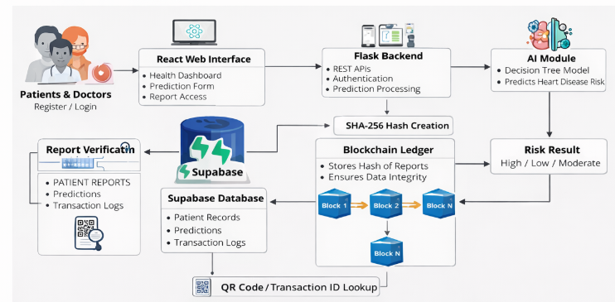

4.2 Module description/decomposition
- Patient Module: Handles patient registration, login, profile management, and input of health parameters for prediction. Output includes prediction results and access to past reports.​
- Doctor Module: Allows doctors to log in, view patient reports, verify report integrity via blockchain, and record consultation notes or recommendations.​
- AI Prediction Module: Receives preprocessed medical attributes as input, applies the Decision Tree classifier, and returns a disease/no disease prediction with risk level.​
- Blockchain / Ledger Module: Converts key report details into a hash, stores it in a ledger table with links to previous hashes, and supports QR-based verification.​
- Telemedicine Module: Supports basic communication and appointment or consultation workflows between patients and doctors, integrated with report viewing.​
- Admin Module: Enables administrators to manage user accounts, monitor transactions, and configure system parameters.

4.3 Database design
The database includes tables for users (patients, doctors, admins), patient medical records, prediction results, ledger entries, and appointment or consultation data. The user table maintains authentication details and roles, while the patient record table stores demographic and health attributes associated with each prediction. The prediction table links to both user and patient records, capturing output labels and risk scores. The ledger table stores hashes, timestamps, and references to related prediction records, forming a chain that ensures integrity. Relationships such as one-to-many between users and predictions, and one-to-one between predictions and ledger entries, are defined using primary and foreign keys.​

4.4 Data flow/control flow
Data flow starts when a patient submits health parameters through the web interface. The backend validates and preprocesses this data and forwards it to the AI prediction module. The model evaluates features, traverses the Decision Tree, and returns a prediction that is then stored with patient details in the database. A hash of the report is generated and stored in the ledger, and a QR code or ID is created. When a doctor or verifier scans the QR code, the system recomputes or retrieves the hash and compares it with the stored value to confirm integrity before displaying the report.​

4.5 UML diagrams set
(You will attach your 14 UML diagrams here; below are sample explanations.)

4.5.1 Use case diagram
The use case diagram shows the main interactions between actors such as Patient, Doctor, and Admin with the system. It illustrates use cases like registration, login, submit health data, view prediction, verify report, manage users, and conduct consultations.​

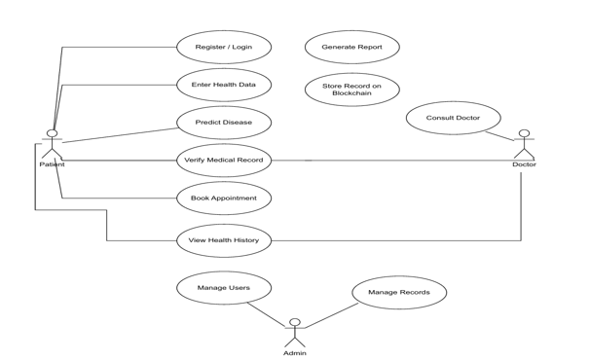

4.5.2 Class diagram
The class diagram represents the main classes, such as User, Patient, Doctor, Prediction, LedgerEntry, and Appointment, along with their attributes and methods. It shows relationships like inheritance between user types and associations between predictions and ledger entries, capturing the static structure of the system.​

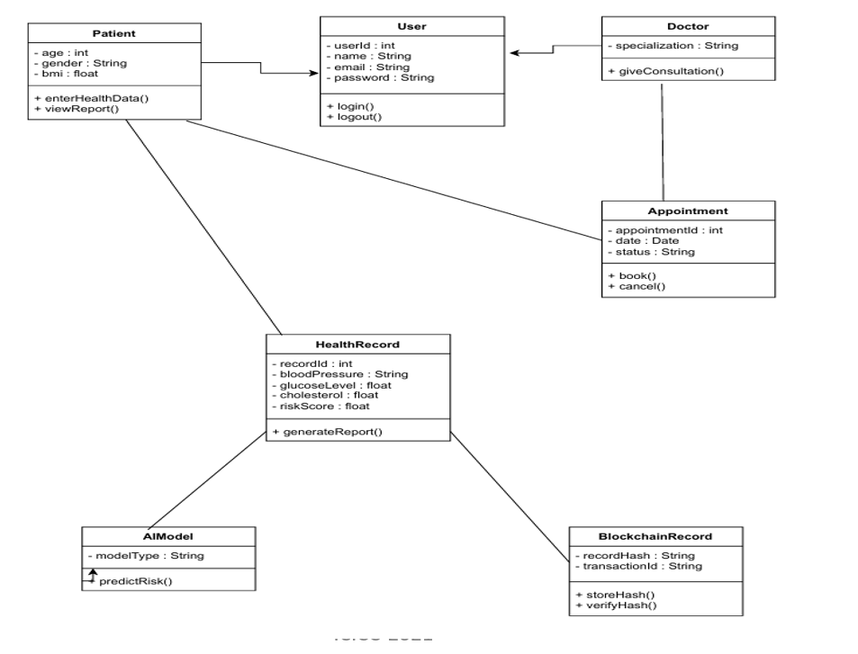

4.5.3 Sequence diagram
The sequence diagram models the order of messages exchanged when a patient submits health data and receives a prediction. It shows interactions between the Patient interface, Backend Controller, AI Service, Database, and Ledger module from request to response.​

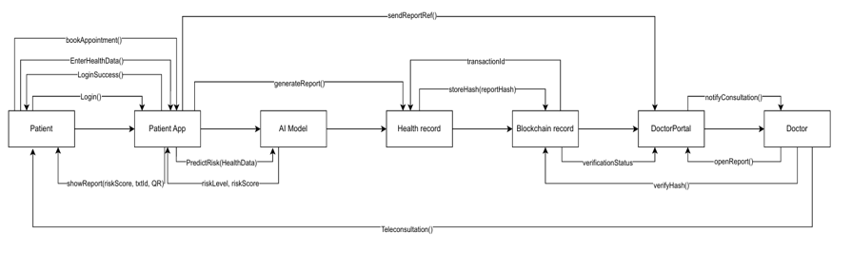

4.5.4 Activity diagram
The activity diagram captures the workflow of heart disease prediction, from user login and data entry to displaying risk results and storing the hash. It highlights decision points such as data validation and conditional flows, like success or error handling.​

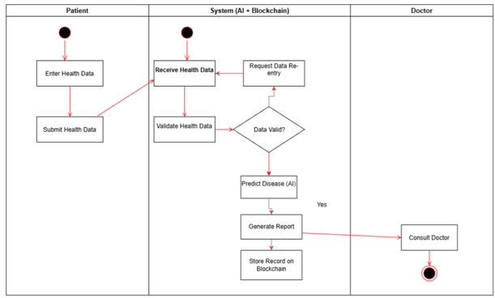
4.5.5 State diagram
The state diagram describes the different states of a prediction record, such as Created, Predicted, Hashed, Verified, and Archived. It shows how transitions occur based on actions like generating prediction, storing a hash, and verifying a report.​

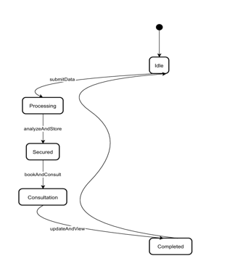
4.5.6 Component diagram
The component diagram illustrates high-level components such as Web UI, Backend API, AI Model Service, Blockchain/Ledger Service, and Database. It shows how these components are organized and how they depend on each other.​

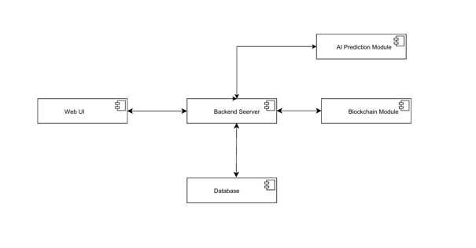

4.5.7 Deployment diagram
The deployment diagram represents the physical deployment of software components on nodes such as client browser, application server, and database server. It indicates which components run on which hardware and how they communicate over the network.​

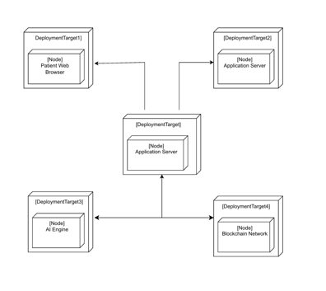

4.5.8 Package diagram
The package diagram groups related classes and components into logical packages, such as UI, Sevices, Models, Blockchain, and Utilities. It clarifies the modular organization of the codebase.​
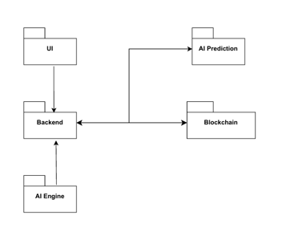
4.5.9 Composite structure diagram
The composite structure diagram shows the internal structure of a key class or component, such as the Backend Controller, including its parts and ports. It helps to understand how internal elements collaborate to fulfil system behaviour.​

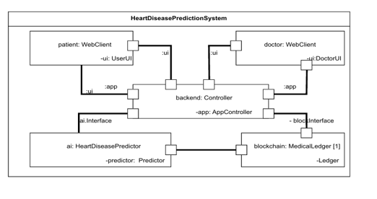

4.5.10 Profile diagram
The profile diagram defines stereotypes and tagged values that customize UML elements for the healthcare and blockchain domains. It can include stereotypes for entities like “HealthcareRecord” or “LedgerTransaction.”​

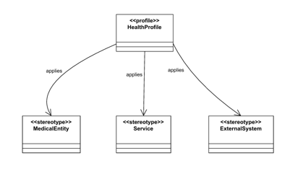

4.5.11 Communication diagram
The communication diagram expresses interactions among objects in terms of links and numbered messages for a typical scenario, like report verification. It complements the sequence diagram by focusing on structural relationships.​

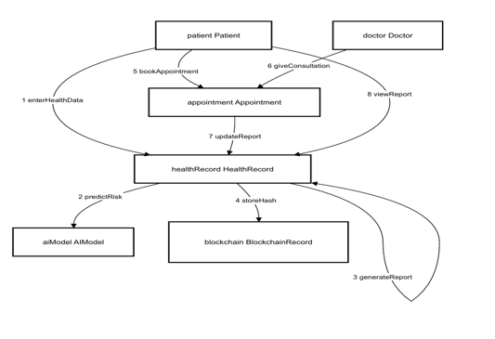

4.5.12 Interaction overview diagram
The interaction overview diagram summarizes multiple interaction diagrams, linking different scenarios such as prediction, telemedicine consultation, and verification. It provides a high-level view of how various interactions connect.​

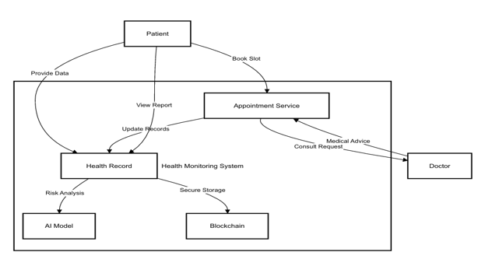
4.5.13 Timing diagram
The timing diagram shows how the state of key objects, such as the prediction record or user session, changes over time during a scenario. It highlights timing constraints and the ordering of events.​

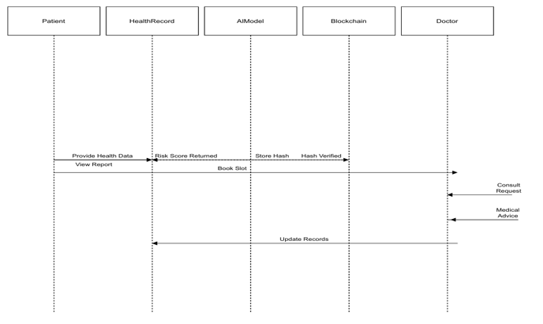

4.5.14 Additional UML diagram
An additional UML diagram, such as another detailed sequence or activity diagram for telemedicine booking, can be used to capture specific behaviour. It illustrates the steps involved when patients schedule and attend an online consultation.​

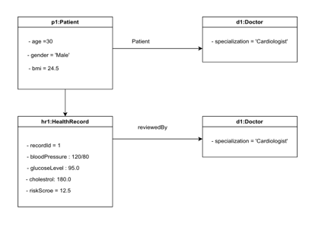

4.6 Design decisions and constraints
The system adopts a web-based architecture to maximize accessibility from different devices and locations. A Decision Tree model is chosen for prediction because it is interpretable and easy to explain to medical practitioners. A private permissioned blockchain implemented as a ledger table with hash chaining is used rather than a public blockchain to maintain confidentiality and simplify deployment. Constraints include limited dataset size, development time, and the need to simulate blockchain logic within the available infrastructure.​

5. System Implementation

5.1 Implementation Environment

Programming Languages
- Python 3.x – Used for backend development and AI/ML model implementation.
- TypeScript – Used for frontend application logic in React.
- HTML & CSS – Used for designing user interface components.
- SQL – Used for database operations and query execution.

Frameworks / Libraries
- Flask – Backend web framework used for REST APIs, authentication, and server logic.
- React.js – Frontend framework used to build interactive web interfaces.
- Tailwind CSS – Used for responsive UI styling.
- Scikit-learn – Used to implement the Decision Tree prediction model.
- Pandas – Used for dataset handling and preprocessing.
- NumPy – Used for numerical and mathematical computations.
- SHA-256 Hashing – Used for blockchain-style ledger security and report integrity.

IDE / Tools Used
- Visual Studio Code (VS Code) – Used for coding and debugging.
- Postman – Used for API testing and verification.
- GitHub – Used for version control and project management.
- Terminal / Command Prompt – Used to run backend and frontend servers.

Operating System
- Windows / Linux – Used as development and deployment environments.

Database / Server Details
- Database: PostgreSQL / Supabase
- Server: Flask Local Server (REST APIs)
- Storage: Patient records, predictions, and blockchain ledger logs

5.2 Module-wise Implementation

5.2.1 User Authentication Module
This module manages registration and login for patients, doctors, and admins. It stores user credentials securely, verifies login attempts, and controls access to different parts of the system based on roles. Inputs include username, password, and role, and outputs are session tokens or access permissions.​

5.2.2 Data Processing Module
The data processing module handles the collection and preprocessing of patient health parameters such as age, cholesterol, blood pressure, and other attributes. It performs checks for missing values, normalizes or encodes features, and prepares them in the format expected by the AI model. The output is a cleaned feature vector ready for prediction.​

5.2.3 Prediction / Analysis Module
This module loads the trained Decision Tree classifier and applies it to the preprocessed patient data. It traverses the tree based on feature values to output a predicted class label (disease or no disease) and may also produce a probability or risk score. The module returns this result to the backend for further storage and display.​

5.2.4 Blockchain / Ledger Module
The blockchain module generates a SHA-256 hash of key report information, including patient ID, prediction, timestamp, and previous hash. It stores this hash and related metadata in a ledger table where each entry references the previous one, forming a chain. It also supports QR code generation and verification by comparing current report hashes with stored values.​

5.2.5 Telemedicine Module
The telemedicine module implements basic features for doctor–patient interaction, such as viewing reports, adding notes, and managing consultation slots. Inputs include patient selection and consultation details, and outputs include updated records and communication logs. This module helps extend prediction results into practical clinical workflows.​

5.3 Algorithm / Pseudo Code
The main algorithm is the Decision Tree-based heart disease prediction flow. At a high level, the algorithm loads the dataset, preprocesses features, trains the Decision Tree classifier, and then uses it in prediction.
High-level steps:
- Load the UCI Cleveland Heart Disease dataset.
- Handle missing values and perform normalization and encoding as needed.​
- Split data into training and testing sets.
- Train the Decision Tree classifier on training data using appropriate splitting criteria such as Gini index or information gain.​
- Evaluate performance on the test set and finalize the model.
- During runtime, accept patient input, preprocess it, and feed it to the trained model.
- Obtain predicted class and risk level.
- Store prediction details in the database and generate a hash for the ledger.​

5.4 Screenshots and Explanation
(In your report, insert screenshots; below are example explanations.)
- Login Page: The login screen allows patients, doctors, and admins to enter their credentials and access role-specific dashboards. It validates inputs and redirects users upon successful authentication.
- Patient Dashboard: The patient dashboard displays options for entering health parameters, viewing previous predictions, and accessing telemedicine features. Results are shown in a simple, understandable format with risk levels and recommendations.
- Prediction Result Page: This screen shows the output of the AI model, including disease/no disease status, risk category, and a summary of submitted parameters. It also provides a QR code or transaction ID for verification.
- Verification Page: The verification page lets users scan a QR code or enter a transaction ID to confirm whether a report is authentic by comparing hash values in the ledger.​

6. Testing and Validation
Testing ensures that the Smart Healthcare System functions correctly, predicts heart disease accurately, and securely stores medical records using blockchain verification. The platform was tested at multiple levels to validate prediction accuracy, module integration, and overall system reliability.

6.1 Testing Strategy
The testing strategy followed a structured approach consisting of:
• Unit Testing
• Integration Testing
• System Testing
Each level verifies different aspects of the system.

6.1.1 Unit Testing
Objective
To verify the correctness of individual modules independently.

Modules Tested
- User Authentication Module
- Data Processing Module
- Prediction (Decision Tree) Module
- Blockchain / Ledger Module
- Telemedicine Module
- Database Management Module

Testing Process
• Login tested with valid credentials.
• Login tested with invalid credentials.
• Patient data preprocessing tested with complete and missing values.
• Decision Tree model tested with sample records for correct risk prediction.
• SHA-256 hash generation tested for consistency and uniqueness.
• Ledger entries tested for proper hash chaining.
• Telemedicine features tested for report viewing and consultation updates.
• Database queries tested for correct insertion and retrieval of records.
Result
All modules produced expected outputs under normal and edge conditions.

6.1.2 Integration Testing
Objective
To ensure that different modules interact correctly when combined.

Integration Scenarios Tested
- Patient data submission → Data preprocessing → AI prediction → Database insertion
- Prediction result → SHA-256 hash generation → Blockchain ledger storage
- Ledger entry → QR code generation → Report verification
- Doctor login → Report access → Telemedicine consultation
Testing Process
•Verified that patient records and prediction results were stored correctly in the database.
• Confirmed that SHA-256 hashes were generated and linked properly in the ledger.
• Ensured that reports were correctly displayed on patient and doctor dashboards.
• Checked that role-based access control restricted unauthorized actions.
• Validated that verification using QR code or transaction ID returned correct report integrity.
Result
All interconnected modules functioned correctly without data loss or mismatch.

6.1.3 System Testing
Objective
To validate the complete system performance and functionality under real-world usage conditions.
System Scenarios Tested
- Multiple patients entering health data simultaneously
- Consecutive AI predictions for different patient records
- Prediction result storage with blockchain hash chaining
- Doctors accessing reports and consultation features
- End-to-end workflow from data input to report verification
Testing Process
• Verified that the entire workflow executed without interruption.
• Checked that predictions were generated accurately and displayed correctly.
• Confirmed that blockchain hashes were created and stored for every report.
• Ensured reports were retrievable through patient and doctor dashboards.
• Tested role-based access for patients, doctors, and admins.
• Validated QR code and transaction ID verification functionality.
• Monitored system response time under multiple user requests.
Result
The complete system operated successfully with stable performance, secure data handling, and accurate predictions.

6.2 Test Cases
Example table format:
Test Case ID | Description | Input | Expected Output | Actual Output | Status
TC01 | Valid patient login | Correct username and password | User logged in and redirected to the appropriate dashboard | As expected | Pass
TC02 | Heart disease prediction with valid data | Complete set of patient parameters | Prediction result displayed with risk level | As expected | Pass
TC03 | Report hash verification | Valid transaction ID or QR scan | Integrity confirmed and report displayed | As expected | Pass
TC04 | Missing mandatory input | Incomplete health parameter form | Error message and request to fill the required fields | As expected | Pass

6.3 Test Results
Summary of Passed/Failed Cases
- Total Test Cases Executed: 6
- Passed: 6
- Failed: 0
- Critical Failures: 0
All major functionalities of the system performed as expected during testing.

Observations
- AI predictions generated quickly.
- Data preprocessing worked correctly.
- Missing values handled properly.
- Hashes generated accurately.
- Ledger records stored securely.
- QR verification successful.
- Workflow transitions were smooth and consistent.

6.4 Validation
Validation ensures that the system’s behaviour matches user and stakeholder expectations. Predicted outputs are compared with known labels in the dataset to check accuracy and correctness. Functional validation is performed by walking through key use cases such as patient registration, prediction, and verification to ensure that the system fulfils its intended purpose. Feedback from potential users or faculty can also be used to validate usability and workflow design

7. Results and Performance Analysis
7.1 Output Analysis
The system generates predictions indicating whether a patient is likely to have heart disease, along with a corresponding risk category. Sample outputs can be represented in tabular or graphical form, showing how predicted risk correlates with input features like age, cholesterol, and blood pressure. Dashboards may include graphs illustrating the distribution of predictions and trends over time.

7.2 Performance Metrics
Model performance is evaluated using metrics such as accuracy, precision, recall, and F1-score on the test subset of the UCI Cleveland Heart Disease dataset. Additional metrics, like a confusion matrix, can be used to analyze false positives and false negatives. From a system perspective, average response time for prediction requests and ledger operations is also considered.​

7.3 Comparative Analysis
A comparative analysis highlights differences between the existing system and the proposed system.
Feature | Existing System | Proposed System
Data Security | Centralized DB, vulnerable to tampering | Blockchain-style ledger with hash chaining, tamper-evident storage
Accessibility | Limited to physical visits or basic portals | Telemedicine interface with remote access to reports and consultations
Diagnosis | Manual assessment by doctors | AI-based Decision Tree prediction supporting early diagnosis
Data Integrity | Difficult to verify | Hash-based verification using QR code or transaction ID
Transparency | Low, limited audit trails | High, with traceable ledger entries and transaction history
​

8. Conclusion and Future Enhancements
8.1 Conclusion
The project successfully implements a smart healthcare system integrating AI-based heart disease prediction with blockchain-style secure medical record management and telemedicine features. Using the UCI Cleveland Heart Disease dataset and a Decision Tree classifier, the system can assist in early diagnosis by analyzing key patient attributes. The blockchain-inspired ledger with hash chaining improves trust by making reports tamper-evident, while the web interface enables convenient access for patients and doctors.​

8.2 Limitations
The current system is developed and evaluated using a relatively small dataset with about 303 records, which may limit the generalization of the model in diverse real-world populations. The blockchain implementation is simplified and runs within a controlled environment rather than a fully distributed network. In addition, telemedicine features are basic and do not yet include advanced options like real-time video integration or integration with hospital information systems.​

8.3 Future Scope / Enhancements
Future work can extend the system to larger and more diverse datasets, include additional medical parameters, and experiment with advanced models such as ensemble or deep learning methods. The blockchain component can be migrated to a more scalable permissioned blockchain framework and integrated with external hospital systems for cross-hospital data sharing.
Telemedicine capabilities can be enriched with live video consultations, prescription management, consent management, digital twin features, and real-time notification alerts to make the solution more comprehensive.​

9. References
You can follow IEEE-style references similar to those in your PPT:​
- Data set from Kaggle at: https://www.kaggle.com/datasets/ronitf/heart-disease-uci.​
- Research papers on AI-based heart disease prediction and cardiovascular risk assessment, IEEE Xplore.​
- Documentation and articles on blockchain applications in healthcare and secure medical record management.​
- Additional journal and conference papers on telemedicine systems and smart healthcare architectures.​

10. Appendix
10.1 Source Code (Sample / Snippets)
In the appendix, you can include key code snippets such as:
- Python code for loading and preprocessing the dataset, training the Decision Tree, and saving the model.
- Flask route handlers for prediction, hash generation, and verification.
- React components for forms and dashboards.
Each snippet should be labelled and briefly explained.
10.2 User Manual
The user manual section should describe:
- Installation steps: setting up Python, dependencies, database, and environment variables.
- How to start the backend server and frontend application.
- Step-by-step instructions for patients and doctors: registering, logging in, entering data, viewing predictions, and verifying reports.
- Screenshots of major screens with short descriptions.
10.3 Abbreviations
- AI – Artificial Intelligence
- ML – Machine Learning
- API – Application Programming Interface
- DBMS – Database Management System
- UI – User Interface
- UCI – University of California, Irvine (dataset repository)
- QR – Quick Response (code)

